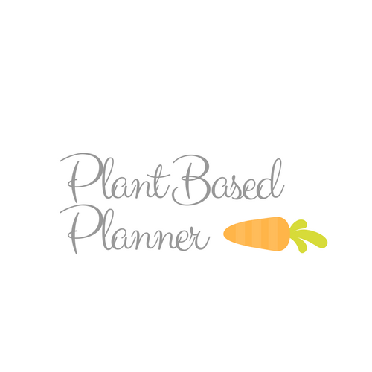
5 Day {Breakfasts} Meal Plan

Grocery List and Recipes Included

Healthy Peanut Butter Granola
https://joyfoodsunshine.com/healthy-peanut-butter-granola/

Ingredients:
- 2 cups old-fashioned (or quick cooking) oats*
- ½ tsp ground cinnamon
- ¼ tsp sea salt
- ¼ cup natural peanut butter
- ¼ cup maple syrup
- ½ tsp pure vanilla extract

Directions:

- Preheat oven to 325 degrees F. Grease a large cookie sheet and set aside.
- In a small bowl, mix together oats, salt and cinnamon. Set aside
- In a microwave safe dish or on the stovetop, melt the peanut butter and honey (or maple syrup) together until smooth.
- Remove from heat and stir in vanilla.
- Stir in dry ingredients and mix until well combined.
- Spread mixture on prepared cookie sheet.
- Bake in the preheated oven for 20-25 minutes, or until granola is lightly browned, stirring the granola once gently half way through. (A great way to test for doneness is to remove a small portion of the granola from the pan and set it on the counter. If it hardens as it cools the rest of the granola is done)!
- Remove from oven and let sit until cooled.
- Once cooled, break apart and eat!

Homemade Raspberry Breakfast Bars
https://www.jessicagavin.com/vegan-whole-grain-raspberry-breakfast-bars/
Ingredients
- 1/2 cup coconut oil softened to room temperature OR Vegan margarine like Earth Balance
- 3/4 cup pure maple syrup or 1 cup brown sugar
- 1 teaspoon pure vanilla extract
- 1/2 cup sliced almonds plus 2 tablespoons for topping
- 1 1/2 cups gluten free flour (or white/whole wheat flour)
- 1 1/2 cups old fashioned oats
- 1/2 teaspoon ground cinnamon
- 1/2 teaspoon baking soda
- 1/4 teaspoon kosher salt
- 1 cup seedless raspberry jam
- 1 cup raspberries fresh
Directions:
- Preheat oven to 350°F. Line a 9x9 inch or 12.5x9 inch pan with foil, lightly grease the foil with vegetable oil or cooking spray. Set aside.
- With a hand mixer or stand mixer with whisk attachment, beat coconut oil and maple syrup on medium-high speed for 2 to 3 minutes, until combined. Add the vanilla and whisk for 30 seconds until incorporated.
- In a separate bowl, combine almonds, flour, oats, cinnamon, baking soda, and salt. Add the dry ingredients to the wet mixture and beat on low speed until blended and crumbly. Remove 1 1/4 cups of the mixture and set it aside.
- Add the remaining mixture into the prepared pan. Use the bottom of a greased measuring cup or your fingers to press the mixture evenly into the pan. Slightly melt the jam in a microwave safe bowl for 15 seconds at a time, stirring in between and continuing to heat until the jam is easily spreadable. Spread the raspberry jam over the crust, and then top with raspberries, distribute the raspberries evenly throughout the pan. Sprinkle the reserved oat mixture over the top and 2 tablespoons of sliced almonds.
- Bake for approximately 25 minutes, or until the top is light golden brown and the jam is bubbling around the edges. Cool completely before cutting into bars. Cut into equal sized squares. Store in an airtight container in the refrigerator for up to 5 days.

Vegan Overnight Oats
http://ohsheglows.com/2015/07/22/vegan-overnight-oats/

Ingredients
- 1 large ripe/spotty banana, mashed
- 2 tablespoons chia seeds
- 1/4 teaspoon cinnamon
- 1/2 cup gluten-free rolled oats
- 3/4 cup almond milk
- 1/4 teaspoon pure vanilla extract (optional)

Directions

- In a small bowl, mash the banana until almost smooth. Now stir in the chia seeds and cinnamon until combined.
- Stir in the oats, almond milk, and vanilla (if using). Cover and refrigerate overnight, or a minimum of 2 hours.
- In the morning, stir the oat mixture to combine. If your Vegan Overnight Oats have a runny consistency even after they soak, simply stir in an additional 1 tablespoon chia seeds and place the mixture back in the fridge until it has thickened up. If the oat mixture is too thick, simply add a splash of milk and stir to combine.

Suggested Toppings:

- Granola
- Fresh fruit
- Coconut flakes
- Pure maple syrup
- Cinnamon
- Nuts and seeds
- Banana soft serve

Pineapple Paradise Green Smoothie
https://www.culinaryhill.com/pineapple-paradise-green-smoothie/

Ingredients
- ¾ cup water
- 2 cups frozen pineapple chunks thawed
- 1 medium ripe avocado halved and pitted
- 2 cups spinach
- ½ cup ice cubes

Directions

Blend and enjoy!

Breakfast Cookies
http://fooddoodles.com/2012/09/11/real-breakfast-cookiesvegan/

Ingredients
- 1 c unsweetened applesauce
- 1 c mashed banana(about 2 large)
- 2 tbsp maple syrup
- ½ C dried cranberries
- ¼ C roughly chopped almonds
- ¾ - 1 C fresh strawberries finely chopped
- 1 tsp cinnamon
- ¼ tsp sea salt
- 1½ C old fashioned rolled oats(certified gluten free if necessary)

Directions
- Preheat oven to 350 degrees. Prepare one baking sheet with parchment paper or a non-stick baking sheet and set aside.
- In a bowl stir together the applesauce, mashed bananas and maple syrup. Add in the dried fruit, nuts and fresh fruit. Sprinkle the cinnamon and salt over the mixture and then stir in the oats. When completely combined, drop 12 - ¼ cupfuls on the prepared baking sheet. They do not spread so place as closely together as possible without touching. Pat the cookies down to about ½" thick and 2.5" around, being sure to press anything that has fallen out of the cookie as it will not hold together.
- Place cookies in the oven and bake for 30 minutes till golden, rotating the sheet around half way through baking. Remove the baking sheet from the oven and let the cookies rest for 5-10 minutes before gently removing them and placing them on a cooling rack.
Notes from the recipe author:
For this batch I added dried apricots, you could also use raisins, dried plums or any of your other favorite dried fruits, as long as they are chopped into raisin sized pieces. Change the flavors by using different spices and fresh fruits! Store any leftovers in the fridge and enjoy them cold. They do get a little sticky after being in the fridge though, due to the fruit.

Grocery List

Produce | Pantry | Cold | Spices
Raspberries | Natural Peanut Butter | Earth Balance Vegan Margarine | Cinnamon
Bananas (at least 3-more for toppings!) | Old Fashioned Oats (2) | Almond Milk
Fresh Fruit of choice (for overnight oats topping) | Maple Syrup | Frozen Pineapple
Fresh Strawberries | Vanilla Extract
Spinach | Sliced Almonds
 | Gluten Free Flour
 | Baking Soda
 | Seedless Raspberry Jam
 | Chia Seeds
 | Unsweetened Applesauce
 | Dried Cranberries
 | Almonds

